# 7. Appendix

Appendix 7.1: ACF and PACF Plot for the Five Variables

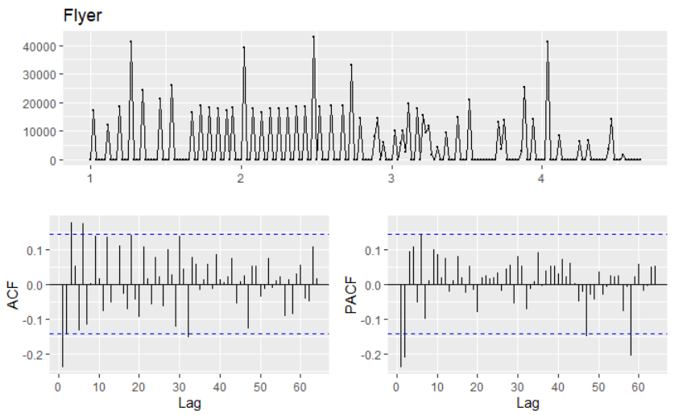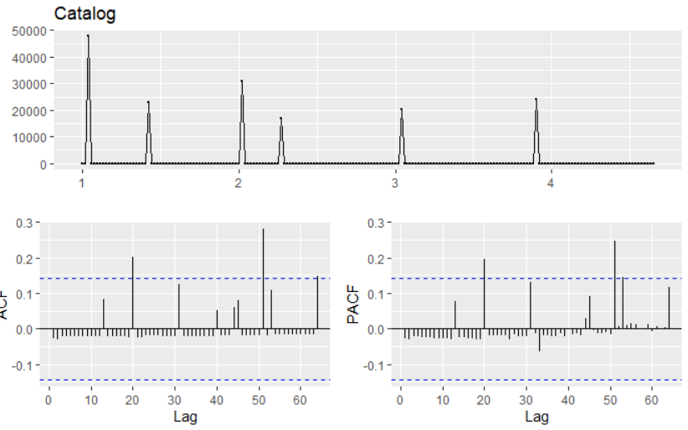

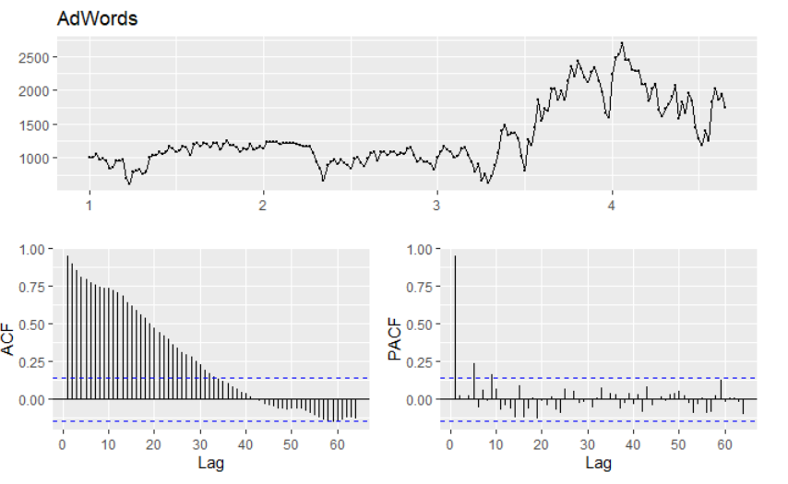 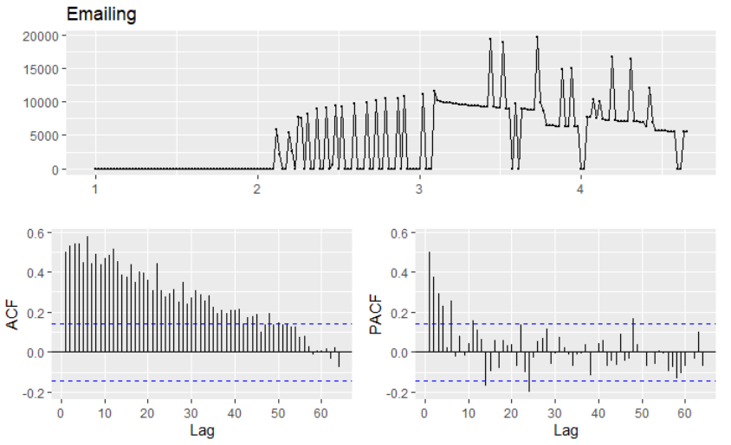 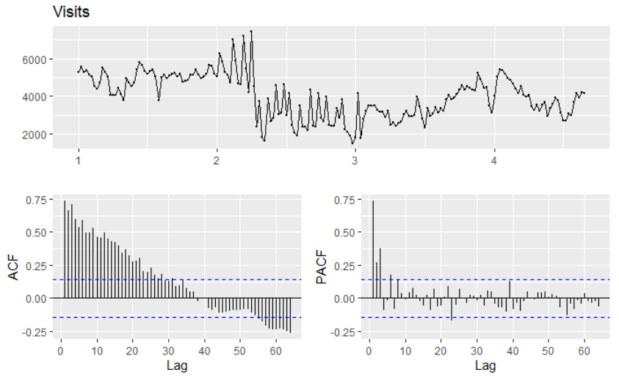

Appndix 7.2: Summary of Var Model

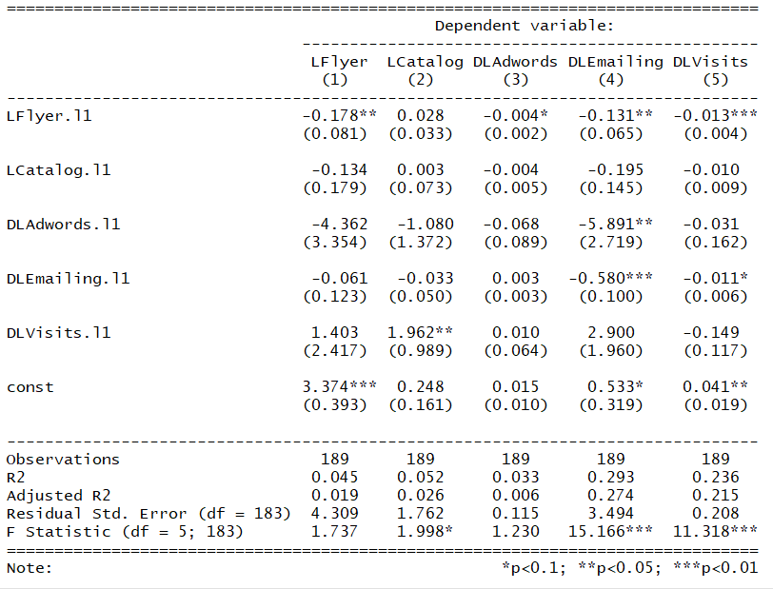

Appendix 7.3: IRF Plots for the Four Marketing Variables

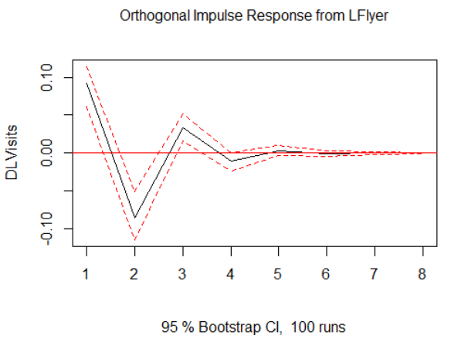 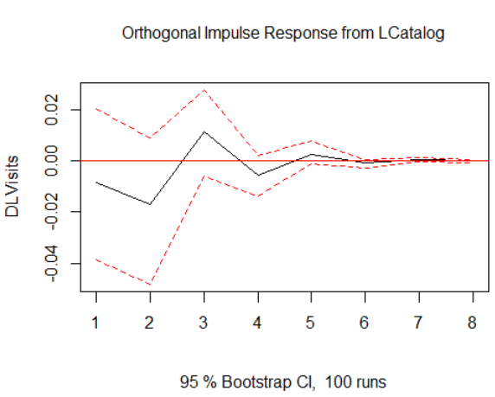

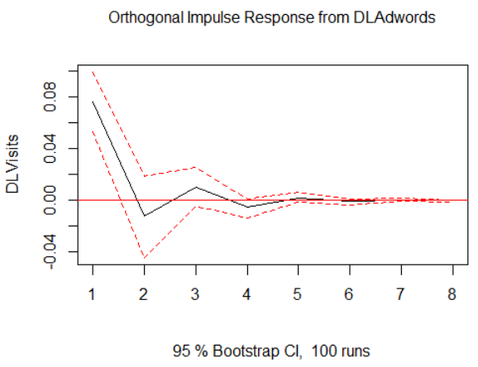 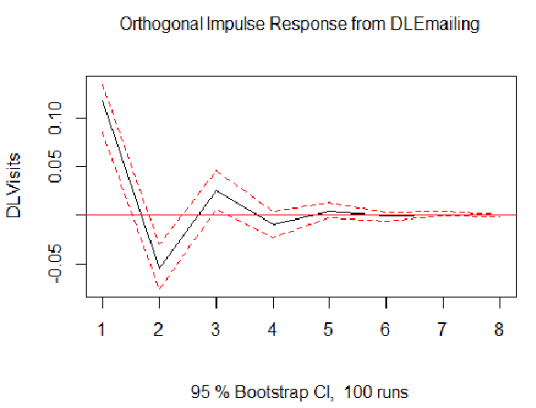

Appendix 7.4：Long-Term Effort of the Four Marketing Tools

|  |  |  |  |  |
| --- | --- | --- | --- | --- |
|  | Flyer | Catalog | AdWords | Emailing |
| Period |  |  |  |  |
| 1 | 0.092 | 0 | 0.076 | 0.117 |
| 2 | 0 | 0 | 0 | 0 |
| 3 | 0.033 | 0.011 | 0.01 | 0.025 |
| 4 | 0 | 0 | 0 | 0 |
| 5 | 0 | 0.0025 | 0.0022 | 0 |
| Cumulative | 0.125 | 0.0136 | 0.088 | 0.142 |

Appendix 7.5: Summary of beginning level, potential stickiness, responsiveness to each marketing tools, conversion for leads, quotes, and orders for both online and offline channels

|  |  |  |  |  |  |  |
| --- | --- | --- | --- | --- | --- | --- |
| Item | Online Leads | Online Quotes | Offline Leads | Offline Quotes | Online Orders | Offline Orders |
| beginning level | 0.206 | 0.048 | 0.118 | 0.226 |  |  |
| potential | 0.794 | 0.952 | 0.882 | 0.774 |  |  |
| stickiness | 0.803 | 0.937 | 0.532 | 0.862 |  |  |
| Responsiveness to Flyer | 0.0082 | -0.0005 | -0.0001 | -0.0004 | 0.0066 | 0.0125 |
| Responsiveness to Catalog | 0.0063 | -0.0004 | -0.0001 | -0.0003 | 0.005 | 0.0173 |
| Responsiveness to AdWords | 0.0431 | -0.0138 | -0.0044 | 0.0167 | 0.0268 | -0.1185 |
| Responsiveness to Emailing | -0.0162 | -0.0077 | -0.0005 | 0.0032 | -0.0003 | -0.0088 |
| Conversion | 0.0629 | 0.004 | 0.0887 | -0.0109 |  |  |

Appendix 7.6: Summary of Appeal of Each Marketing Tools

|  |  |  |  |  |
| --- | --- | --- | --- | --- |
|  | Online Leads | Online Quotes | Offline Leads | Offline Quotes |
| appeal_Flyer | 0.002079 | 0 | 0 | 0 |
| appeal_Catalog | 0.001597 | 0 | 0 | 0 |
| appeal_Adwords | 0.010927 | -0.00083 | -0.00074 | -0.00102 |
| appeal_Emailing | -0.00411 | -0.00047 | 0 | -0.0002 |

Appendix 7.7 Forecast of Online Order

|  |  |  |  |  |  |
| --- | --- | --- | --- | --- | --- |
|  | Start | New | Gain | LRGain | Conversion |
| Flyer | 4790 | 5843.8 | 1053.8 | / | / |
| Catalog | 854 | 819.84 | -34.16 | / | / |
| Adwords | 1325 | 1086.5 | -238.5 | / | / |
| Emailing | 4320 | 4320 | 0 | / | / |
| Online_Leads | 0.206 | 0.204526 | -0.00715 | -0.31655 | -0.01991 |
| Online_Quotes | 0.048 | 0.048128 | 0.002659 | 0.033197 | 0.000133 |
| Online_Order | 85.69 | 85.32999 | -0.0042 | -0.00771 | / |

Appendix 7.8: Forecast of Offline Order

|  |  |  |  |  |  |
| --- | --- | --- | --- | --- | --- |
|  | Start | New | Gain | LRGain | Conversion |
| Flyer | 4790 | 5843.8 | 1053.8 | / | / |
| Catalog | 854 | 819.84 | -34.16 | / | / |
| Adwords | 1325 | 1086.5 | -238.5 | / | / |
| Emailing | 4320 | 4320 | 0 | / | / |
| Offline_Leads | 0.118 | 0.118101 | 0.000858 | 0.037953 | 0.003366 |
| Offline_Quotes | 0.226 | 0.225237 | -0.00338 | -0.04214 | 0.000459 |
| Offline_Order | 85.69 | 87.88525 | 0.025619 | 0.047032 | / |